Introduction to Automotive

Report

Lab 3: ABS

|  |  |
| --- | --- |
| Student Name | Ahmed Mohsen Abd El Fattah |
| ID | 1901061 |

# Anti-Lock Braking System:

ABS is a safety algorithm that aims for keeping the wheels from locking, it is done by monitoring the accelerations and decelerations of each wheel individually in the vehicle, based on the value of the acceleration the system acts to increase or hold or decrease the brake pressure to keep the wheel from locking which in turn decreases the slipping, minimizes the stopping distance and keeps the vehicle in control.

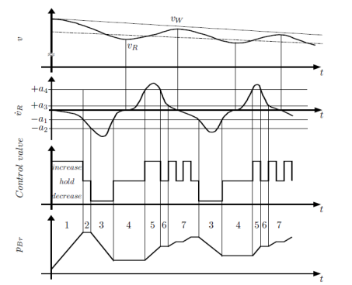

Figure 1 ABS Cycle

# MATLAB Snippets:

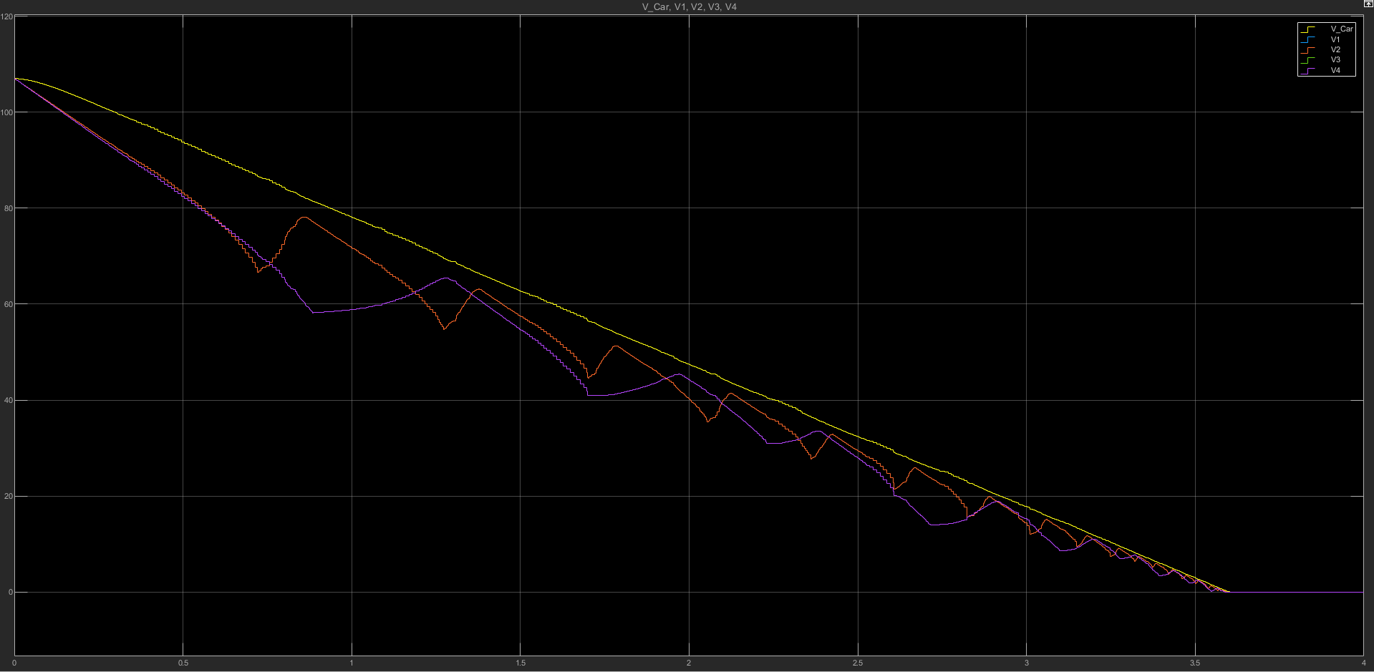

Figure 2 Car Speed vs Front and Rear Wheels Speed

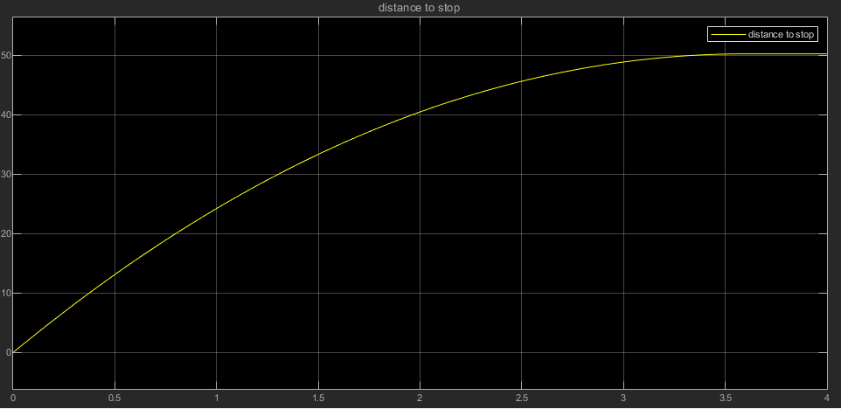

Figure 3 Distance to Stop

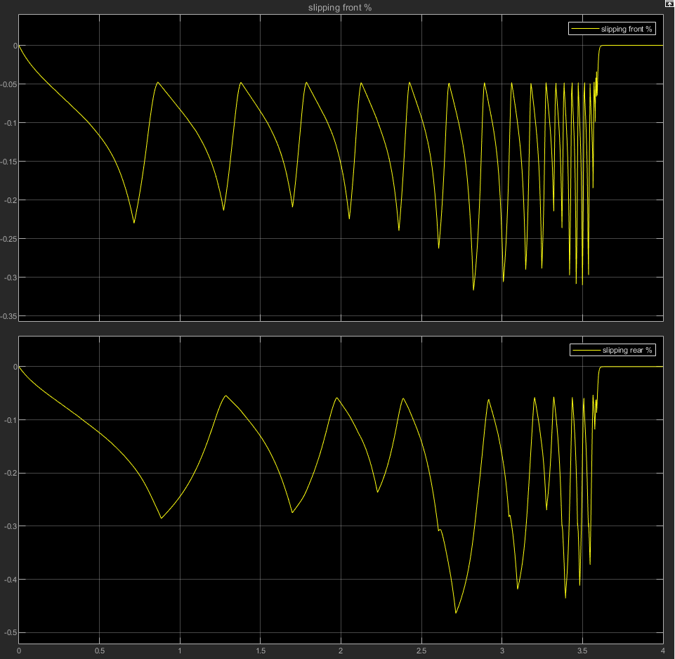

Figure 4 Slipping Front and Rear

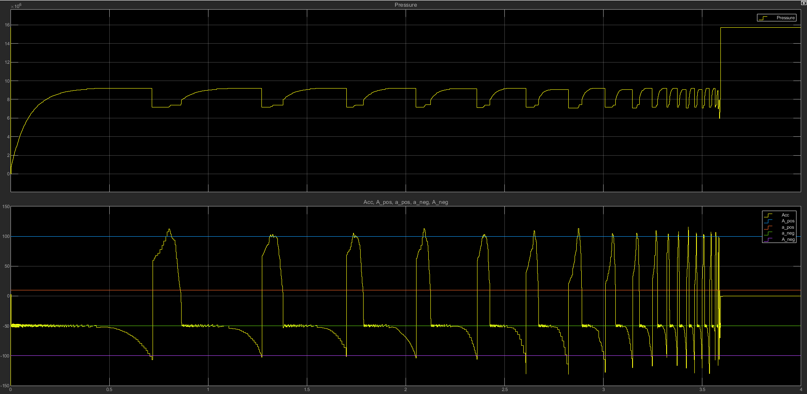

Figure 5 Front Wheels Brake Pressure and Acceleration

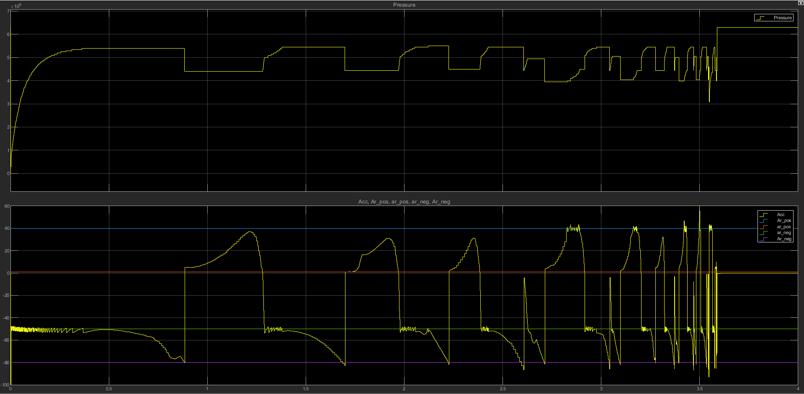

Figure 6 Rear Wheels Brake Pressure and Acceleration

# Comments:

* Stopping distance is minimized even when the pedal value is 1 which is the maximum brake pressure value, while locking occurs at 0.56 without ABS.
* Wheel locking is prevented.